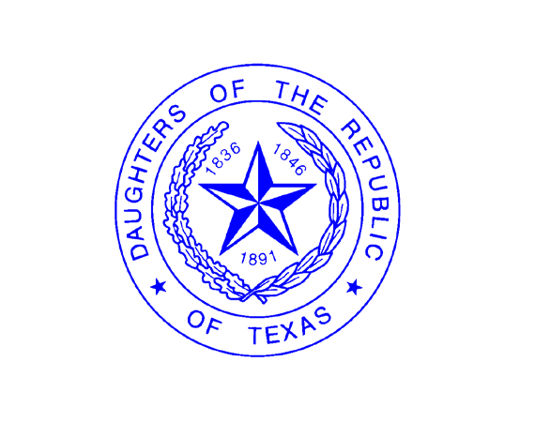

**DAUGHTERS OF THE REPUBLIC OF TEXAS SAN JACINTO CHAPTER**

**Thelma Maresh Scholarship 2025 Application Procedures**

The goal of the Thelma Maresh Scholarship Program is to recognize and award scholarships to graduating students in the Greater Metropolitan Area of Houston who are extraordinary leaders, outstanding scholars and responsible citizens. Awards will be presented on April 21, 2025, during the San Jacinto Day Commemorative Ceremony at the San Jacinto Monument, San Jacinto Battleground State Historic Site.

# Criteria for Selection

The scholarship committee will seek the most promising student leaders with potential for providing exceptional contributions to the college or university that he/she will attend and to the world at large. The selection will be based on:

1. leadership
2. scholarship
3. responsible citizenship

In addition to these criteria, the scholarship committee is interested in the applicant’s educational and career plans, life philosophy, volunteerism, motivation and determination. Financial need will also be considered if mentioned.

# Eligibility

1. Must be a high school senior who will graduate before June 30, of the current school year.
2. In recognition of the Texas heritage of our organization, only students attending a **4-year Texas** college or university will be considered.
3. Must be a citizen of the United States.
4. Must have a **minimum Grade Point Average of 3.0.**
5. Must exemplify achievement, leadership, and potential for college and career.

# Application Procedures

1. Download the scholarship application (fillable pdf) and application procedures (pdf) to your computer. You can choose to fill out the pdf online or print it out, fill it in by hand and scan it back onto your computer. If you fill it in by hand, make sure your handwriting is legible.
2. Create an email and attach the following: application form, high school transcript, score reports, photograph, personal narrative and letters of recommendation. (Letters of recommendation can be emailed separately **if** coming directly from the letter writers.)
3. Email your **complete** application packet to [sjcscholarship@yahoo.com.](mailto:sjcscholarship@yahoo.com) **In the subject line of your email, please write “your name – DRT Scholarship application”.**
4. If you choose to complete the application process in hard copy, your complete packet must be postmarked on or before March 10, 2025 to: DRT Scholarship Committee, 1510 Cambridge Street, Houston, Texas 77030. Do not send by registered mail.
5. Provide high school transcript(s) and copy of SAT/ACT Test Results. Test Results may be on transcript or a copy of your score report sent to you from the test center. Transcript(s) should show final grades for all courses taken from 9th grade to most recently completed semester in high school.
6. Provide two letters of recommendation: one recommendation from an academic person and one from a non-family member.
7. Submit a typed narrative supporting your life goals and experiences. See application form for narrative instructions.
8. Scholarship recipients will be notified prior to April 10, 2025. If you would like to know if you are a recipient, you may email [sjcscholarship@yahoo.com](mailto:sjcscholarship@yahoo.com) after April 10, 2025.
9. The scholarship committee reserves the right to interview applicants as part of the application process.

**Scholarship Award Checks** will be issued to you beginning June 1, 2025, **after** you provide a fee receipt with your name on it to the Scholarship Committee Chair. Additionally, scholarship recipients must provide a class schedule to the committee prior to the last day of September as proof of course registration.

**For Scholarship Applications/Information, contact:** Mrs. Laura Kaplan [sjcscholarship@yahoo.com](mailto:sjcscholarship@yahoo.com)

[**www.sanjacintodrt.org**](http://www.sanjacintodrt.org/)