The San Jacinto Dispatch

Daughters of the Republic of Texas October 2015

**From the President**

Dear Daughters,

At last autumn has arrived with all of its treasures for us to enjoy. Even the word autumn sounds beautiful, we can expect all of the gorgeous colors of this wonderful season. The leaves turning red and orange, softer yellow sunlight, the golden glow of a big Harvest Moon, and pumpkin everything! Surely she will charm us, how could we resist?

This season brings us back to the Log House and begins our DRT year. Members have enjoyed a long “DRT Break” since our June luncheon and are anxious to get back to Chapter Meetings and fun events. Our Executive and PMLHM Board members have been busy this summer taking care of all that is required to make our DRT year successful.

Program chair, Ann Tanner, has planned interesting programs and has a field trip up her sleeve for us to enjoy. The grounds look lovely with of all the wonderful care given by Margie Forster. Leah Jorgensen will have the yearbook ready for us very soon. Carolyn Lightfoot has spent her summer preparing for our party/ fund raiser, “Come and Sip It” on October 24th to benefit the Log House. Buy your tickets and plan to attend.

Deborah Liss-Frank and Luanne Zacek have an exciting year planned for our CRT children. The children are always welcome to bring a friend along to the Log House.

Marje Harris generously gave her time to present her Genealogy Course. Everyone who attended has learned new ways to find their roots and had so much fun! Thank you, Marje.

This summer was tough on the Log House. It was without electricity and air conditioning for six weeks. The phone was also not working and is still in the process of being repaired. This prevented the house from being opened by our docents for guests and completely shut down our rental business. Hopefully, we will be good to go on all points very soon.

My very special thanks to the Board members for all they do. I am looking forward to seeing everyone at Chapter meetings.

Jamie

November 5th Meeting

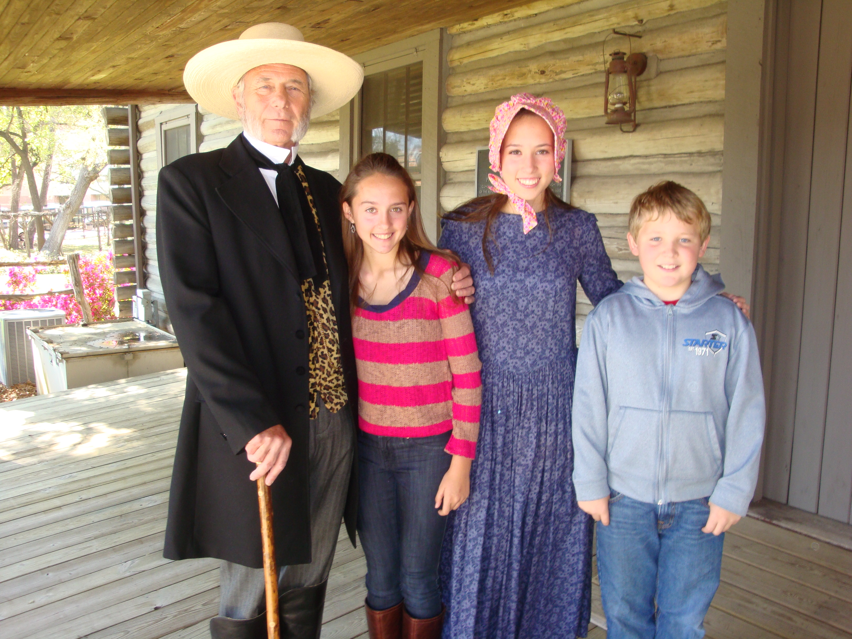

**Mr. Scott Griffin**

Please join us at the Log House on November 5th to hear Scott Griffin speak on *“San Jacinto: Its Importance, Legacy, Descendants.”*

Scott Griffin is a native Texan. Scott and his wife, Ginger, came to Katy in 1971 to pursue their careers in Education where Scott was a teacher and a coach until retiring in 2003.

Scott taught Texas history for the majority of his teaching career. Scott played the part of General Sam Houston in the recent Houston biography. Dressed in character, Scott has visited San Jacinto Chapter to participate in Sam Houston biography program in 2012 and in our first Pioneer Days in 2013.

Scott is remembered by his students as a "hands-on teacher," bringing artifacts, clothing, and antiques from the early Texas era to school for his students to see, touch, and feel and having Texas history days with open fire cooking demonstrations, butter making, hoe cakes, vinegar pies and other foods from the early Texas frontier era.

*Ann Tanner, Program Chair*





Inside This Issue

|  |  |
| --- | --- |
| **P. 2** | San Jacinto Chapter Meetings & Events; CRT Events |
| **P. 3** | Christmas Luncheon; San Jacinto Chapter Contributors |
| **P. 4** | Log House Open House & Rentals; Executive Board Meeting; Former Lt. Gov. Hobby Speaks to Chapter |
| **P. 5** | Proposed Bylaw Amendment; Registrar's Report;  Texas Honor Days, PMLHM Contributors |
| **P. 6** | 2015 Report on Log House Maintenance & Repairs |

Special Events   
for San Jacinto Chapter   
2015-2016

**Saturday, October 24, 2015 (2-6 pm)**

Come and Sip It!

\*See details below

**Tuesday, December 1, 2015 (1 pm)**

Baked Potato Lunch / Log House

and tree decorating

**Thursday, December 3, 2015 (11:30 am)**

Chapter Christmas Luncheon

**Sunday, December 6, 2015 (2-4 pm)**

PMLHM Christmas Open House

**March, 2016 (Spring Break)**

Texas History Pioneer Days

**Thursday, April 21, 2016**

San Jacinto Day Ceremony with presentation

of the Thelma Maresh Scholarships

**Saturday, April 23, 2016**

San Jacinto Day Festival and Battle Reenactment

**Sunday, May 8, 2016**

Reception for Texas History Essay

Winners

**2015-2016**

Chapter Meetings

& Programs at the Log House

*San Jacinto Chapter meets at the Pioneer Memorial Log House. Hospitality begins at 10:00 a.m.   
The business meeting/program   
starts promptly at 10:30 a.m.*

**Thursday, October 1, 2015**

President’s Report on the Log House

Program: Former Lt. Gov. Bill Hobby  
*“Threads of History: The Raven””*

**Thursday, November 5, 2015**

Program: Scott Griffin,  
*“San Jacinto: Its Importance, Legacy, Descendants”*

**Thursday, December 3, 2015** (**11:30)**

Christmas Luncheon

Musical Presentation & New Member Ceremony

**Thursday, January 7, 2016**

Program: Tom Wilson,  
*“Miss Ima Hogg: The Great Texan and Collector”*

**Thursday, February 4, 2016**

Program: Janet Tucker,   
*“Three Brothers’ Bakery”*

**Thursday, March 3, 2016**

Field Trip to tour Columbus Opera House and the Dilue Rose Harris House

**Thursday, April 7, 2016**

Program: Jamie Wolman,   
*“Keeping Texas Beautiful”*

**Thursday, May 5, 2016**

Chapter Memorial Service

Program: Eron Tynes,   
*“Texas Moment””*

**Thursday, June 2, 2016** **(11:30)**

June Luncheon, Lakeshore Country Club

New Member Ceremony & Convention Report















**Celebrating the Seasons**

**Children of The Republic of Texas**

**October 31, 2015**

10:00 to 11:30

CRT Halloween Costume Party

*Contact Deborah Liss-Frank*

*for details 832.755.5550*

**Sunday, December 8, 2013**

2:00-4:00

PMLHM Christmas Open House

**March, 2016 (Spring Break)**

Texas History Pioneer Days

**Saturday in May or June, 2016**

CRT Celebrates Summer - Field Trip

Watch for details

Halloween,holidays,jack-o'-lanterns,pumpkins,special occasions

**Make Your Plans to Attend**

Saturday, October 24, 2015

**Come and Sip It!\***

2:00 to 6:00 at the Log House

Tickets: Adult $35; Children under 12 $10

Music, Silent Auction, Prizes, Good Food

\*Fund raiser for the Pioneer Memorial Log House

***Make your Christmas Luncheon Reservation by November 25th***

**\_\_\_ \_\_ Number of Reservations @ $25.00 Per Person $ \_\_\_**

Make your check payable to: Send to: *Brenda Stover*

San Jacinto Chapter *13515 Kimberley Lane*

*Houston, TX 77079-6005*

**\_ \_ \_ \_ \_ \_ \_ \_ \_ \_ \_ \_ Clip Here\_ \_ \_ \_ \_ \_ \_ \_ \_ \_ \_ \_**

**SAN JACINTO CHAPTER**

**Contributors: June—Sept**

**Contributors**

Carolyn Abernathy Gwen Kunz

Isabell Andrews Dolores Landrum

Elizabeth Arp Susan Lemon

Sharyn Baker Amy Leuders

Anne Baldwin Marilyn Luther

Amanda Barton Tamara Phillips Mailloux

Nancy Barton Kay Martin

Martha Sue Bodine Peggy McGinty

Lisa Braly Mary Sue Montgomery

Anne Brent Miki Norton

Bette Burkett Elysee Peavy

Bana Caskey Sylvia Peebus

Marilyn Jones Chapman Betty Petty

Dorothy Cagle Caroline Prince

Alice Calderon Martha Rogers

Rose Calhoun Juanita Santos

Bana Caskey Diana Stachowiak

Marilyn Jones Chapman Margaret Standard

Laura Wood Cox Martha Strang

Poppy Doyle Charlotte Taylor

Charlene Dwyer Laura Hill Taylor

Jane Fieldcamp Francita Ulmer

Marjorie Forster Mary Ann Walker

Susan Gaze Sandra Wellen

Vickie Gilbreath Mary Sue Westmoreland

Shelley Gottschalk Sharolyn Wood

Carol Haddock Jimmie Wootten

Martha Hirsch Lynn Young

Gwen Koch Camille Dabaghi Shannon

**Memorials and Honorariums**

Clare Deaver –in honor of Sally Whittington

Cynthia Hawkins – in memory of Beverly Kraft

Angela Orlando – in memory of Larry F Orlando, husband

Nancy Peebles –in memory of Julia Garcia Aguilar

Brenda Puckett – in memory Judy Calvin

Constance Seger – in memory of Mary Jane Harmon

Julia Beckie Stockstill-Cobb – in memory of Mary Dell Rosier

Carol Theilen – in memory of Kae Theilen

**Christmas Luncheon**

**Dec. 3 at 11:30   
at the Log House**



Make plans to attend our Annual Christmas Luncheon and enjoy good food, good fellowship, and a terrific musical program.

Mail your check made out to San Jacinto Chapter/DRT for $25 to:  
Brenda Stover, 13515 Kimberley Lane, Houston 77079.

**MENU**

Virginia Ham  
Sweet Potato Casserole

Asparagus Bundles

Congealed Salad  
Dinner Rolls  
Cheesecake with Three Berry Sauce  
Tea/ Coffee

Checks due by WednesdayNovember 25, 2015

*Bring an unwrapped child’s toy*

*Free parking in Ben Taub Garage*



**Executive Board Meets**

**At Taste of Texas**

With no electricity at the Log House this summer, the San Jacinto Chapter Executive Board held its August board meeting at the Taste of Texas, finalizing plans for the 2015-2016 chapter year. The July board meeting was held at Clayton Library.

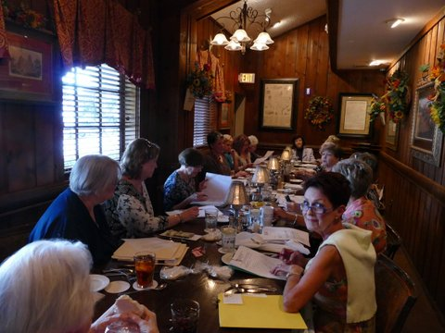

President Jamie Moran holds

Board Meeting at Taste of Texas

**Pioneer Log House**

**Open House & Rentals**

***Monthly Open House:*** San Jacinto

Docents open the Pioneer Log House

Museum for tours on the 3rd Saturday

each month – Saturdays from 1-3 pm.

Beth McCarthy and Carolyn Gilbert serve as chairs of the San Jacinto Chapter Docents Committee for 2015-2017. At the October Open House, Beth and Carolyn greeted over 50 visitors.

Our docents put out the flags and open the front doors of the Log House to greet our visitors and to invite them in for a brief tour, explaining our Log House and our museum.

If you would like to participate as a docent, learning about our Log House and Museum, please contact Sharolyn Wood, at 713-305-2750 or woodsharolyn@aol.com.

***Rental and Tours:*** The Log House is available for rental for meetings, receptions, dinners, parties and other special events.

Individuals and groups may rent the Log House and grounds for reasonable rates. Rates for chapter members or patriotic groups is $150. The Log House looked great all decked out for a baby shower recently. Earlier this summer, the Log House was the perfect site for a Texas style wedding.

Luanne also schedules tours for interested groups.

A Master Gardener group recently toured the Log House. They were very impressed with the Log House and the grounds that Margie and her volunteers keep looking great.

Rent the Pioneer Memorial Log House or schedule a tour by calling Luanne Zacek at (281) 391-8464 or [lzacek@hotmail.com](mailto:lzacek@hotmail.com).

Thanks to Luanne, Beth, Carolyn, Margie, and our Docents who help with our rentals. Income from these rentals helps support Log House repairs and maintenance.



**Former Lt. Gov. Bill Hobby**

**Speaker at Oct. Chapter Meeting**

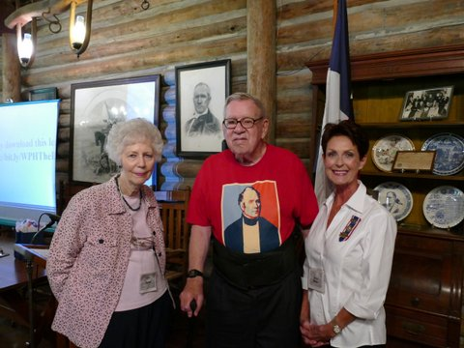

Mr. Hobby with Ann Tanner & Jamie Moran

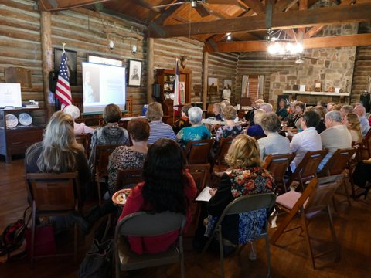

A full house enjoys the "Threads of History" based on San Houston's life story and Texas Independence

Need a Nametag?

Contact Angela Mahmarian

[amgiraffe@](mailto:amgiraffe@)aol.com

if you need a nametag.

C:\Users\lbeve_000\AppData\Local\Microsoft\Windows\Temporary Internet Files\Content.IE5\52K5LRUA\MC900319960[1].wmf

Texas Honor Days November

**Proposed Amendment to**

**Chapter Bylaws: 2015 – 2017: #1**

The following amendment was read at the October Chapter Meeting. A vote on the proposed amendment will be at the November 5th Chapter meeting.

Article III – Membership

Section 1. Classes of Membership

**G. Affiliate Member**

**Section 8. Affiliate Member**

**A member of a DRT chapter other than San Jacinto Chapter who wishes to have a secondary chapter membership in San Jacinto Chapter as an Affiliate Member must have her name presented and voted upon, conforming to the rules governing new applicants.**

Comments: This would be a new section in the Bylaws. In 2014, State DRT created the membership class for an “Affiliate Member.” San Jacinto Chapter has had inquiries by former members who are now members of chapters in other Texas cities.

The Board and Chapter membership approved an Affiliate Membership for Carolyn Raney when she requested affiliate membership in 2014.

The 2014-2015 Executive Board set dues for an Affiliate Member at $15 per year. When the Bylaws are amended to officially create this new membership class, The Board has approved amending “Standing Rule 2. The schedule of dues and fees” for the Chapter to begin collecting the dues with suggested language*: “Annual Chapter dues for an Affiliate Member are $15.”*

***Fly your Texas flag!***

**S**

**Stephen F. Austin’s Birthday** 1793 **November 3**

**DRT Founders Day,** 1891 **November 6**

**Registrar's Report**

San Jacinto Chapter welcomes

our new members.

**Acosta, Erin Nicole**

#31584   Approved: July 2015

Ancestor: Juan Jose Palacios

Sponsors:       Ann Tanner; Marje Harris

**Santos, Teresa**

#31591 Approved:  July 2015 Ancestor:       Julian Flores

Sponsor:       Marje Harris

**Stormer, Susan**

31671 Approved 26 Aug 2015

Ancestor: John Sutherland

**Kelly, Grace Anita Doyle**

31679     Approved: 02 Sep 2015

Ancestor: Mary Ann Warrick

Erin, Teresa, Susan, and Grace are our first members approved in the 2015-2016 Chapter Year.

San Jacinto Chapter currently has 292 members.

*Marje Harris, Registrar*





**PIONEER MEMORIAL LOG HOUSE MUSEUM -- Contributions June 1 – Sept. 24, 2015**

**Friends Memorials and Honorariums**

Goke Akinniranye Delores Hays Landrum Sharon R. Stoerkel – In Honor of Luanne Zacek

*(for Tx Heritage Garden)* Julie Martinez Gina Bouchard– In Honor of Phyllis Moody

Anna S. Baldwin Elizabeth G. McCarty Martha Jorgensen– In Honor of Phyllis Moody

Anne Brent Margaret McGinty Laura Stover – in Memory of Roxalee Smith Andrews

Bobbye Burke Jamie Moran Lisa H. Braly– In Memory of Ellyer M. Hansen

Betty Burkett Elysee H. Peavy Sue Montgomery– In Memory of Dorothy Dickson

Dorothy Cagle Betty Petty Angela Orlando– In Memory of Larry Orlando

Laura Cox Caroline Prince Meg Sparks– In Honor of Sally Whittington

Charlene Dwyer Meg Sparks **Come and Sip It! Fund Raiser**

Jane Fieldcamp Meg Sparks Kay Martin

Margie Forster Diana Stachowiak Lightfoot Family Living Trust

*(for Tx Heritage Garden)* Martha S. Strang Davis Bros. Construction

Susan GazeAnn TanneDarlene East, Holes, Inc.

Shelley Gottschalk Charolotte Taylor John H. Kauffman/Dr. Martha Jane Fayland

Martha Haydel Sandra Wellen William R. Sudela

Gwen Kunz Sally Whittington J. D. Joyce Investment Management Group

Sharolyn Wood

***Air conditioner.*** A significant casualty of the electrical power problem is that air conditioner unit #3 at the Log House was “burned out” due to a power surge and cannot be rebuilt. The Board of the PMLHM is considering alternatives. We have a bid of approximately $20,000 from one company to build and install one new unit to replace unit #3 which is not working. The estimate to upgrade all four units is over $75,000. This is a long range funding issue.

***Damage*.** Vibrations from the generator used at the Log House this summer are the most likely cause of damage to items in our Log House collection. The Davy Crocket wall cabinet fell from the wall. We are optimistic that the statuary can be restored. A decorative piece on the tall table in the dining room fell, hitting the antique lamp shade, leaving a large broken piece which we hope can be repaired.

***Telephone line.*** In an unrelated event, the Log House has lost telephone service. Our phone line has been severed somewhere between the “box” at the Zoo and the Log House. One problem with Zoo equipment was been located; yet that repair did not restore service.

Gwen Kunz, PMLHM Treasurer, has worked tirelessly with our phone company, AT&T, and the Zoo to restore service. AT&T must first find where the line is severed before it can be repaired.

***Keurig coffee*.** Our single serve coffee maker has been a “hit” at Log House events. Members and guests can select from several coffee choices, including decaf. Special thanks to Carolyn Lightfoot, President of the Friends of the Log House and Past President of San Jacinto Chapter, for donating the coffee maker.

***Linens.*** We have worked this summer to inventory and organize the table cloths and linens in the Log House collection. We have new storage and have “re-discovered” pieces which we will be using at Log House events.

***Improving drainage*.** We have all been aware of the drainage problem under Brooks Cottage and our tool storage shed. This summer, the water damaged ramp into the shed was replaced.

Additionally, the down spouts from the Cottage roof gutters were rerouted into a pipe laid under the parking lot. The pipe empties out onto the lawn. This has helped eliminate much of the water which was accumulating under Brooks Cottage. After a rain, water not diverted into the drainage pipe will continue to stand until evaporated. This low spot on the Log House property will continue to be a problem—just much less so.

*Sharolyn Wood*

*5th Vice President, SJC*

*Executive Vice President, PMLHM*

2015 Report on

Pioneer Memorial Log House Repairs and Maintenance

**

Yesterday, Today & Tomorrow

blooming near the Log House back door

***Grounds.*** Our grounds continue to look lovely due the hard work of Margie Forster, our 6th Vice President, and her volunteers. Thanks go out to our members and the Rose Society members. Margie has improved the overall health of our beds with her fertilizer program. With the help of Gwen Kunz, Margie has trimmed back the grape arbor. It looks great. Our magnolia tree is lovely now that the “volunteer” sweet gum tree has been removed. And….our roses are thriving.

***Electricity loss.*** The “big event” this summer was the loss of all electrical power at the Log House on July 9, 2015, when the Hermann Park transformer located on the grounds of the PMLHM failed. The City of Houston is in the midst of the lengthy bid, fabrication, installation process to install a new transformer. The new transformer should be installed in December, 2015.

When the transformer failed, the Log House lost electric power for over six weeks. As a temporary, stop-gap measure this summer, a large generator was moved on site to power Brooks Cottage and provide enough power to run the refrigerator in the Log House during those weeks without electricity. We had no power for lights or air conditioning. Board meetings were held at other locations. All rentals and other activities scheduled at the Log House this summer were cancelled.

Our president, Jamie Moran, worked tirelessly with the Hermann Park staff to find this short-term, generator solution while the power was out and, as an interim solution, to have power restored this fall while we wait for the new transformer to be installed. At one point last summer, Jamie was being told by Zoo officials that we would not have power at the Log House until December. Thank you Jamie for getting the Log House up and running again.